In April in Children’s Chapel we will focus on topics of stewardship: How God cares for us and how we care for ourselves, our neighbors, our home, our church, and our earth.

Stewardship is a fancy work for taking care of something that doesn’t belong to you.

Bible Verse: “As each has received a gift, use it to serve one another, as good stewards of God’s varied grace.” (1 Peter 4:10).

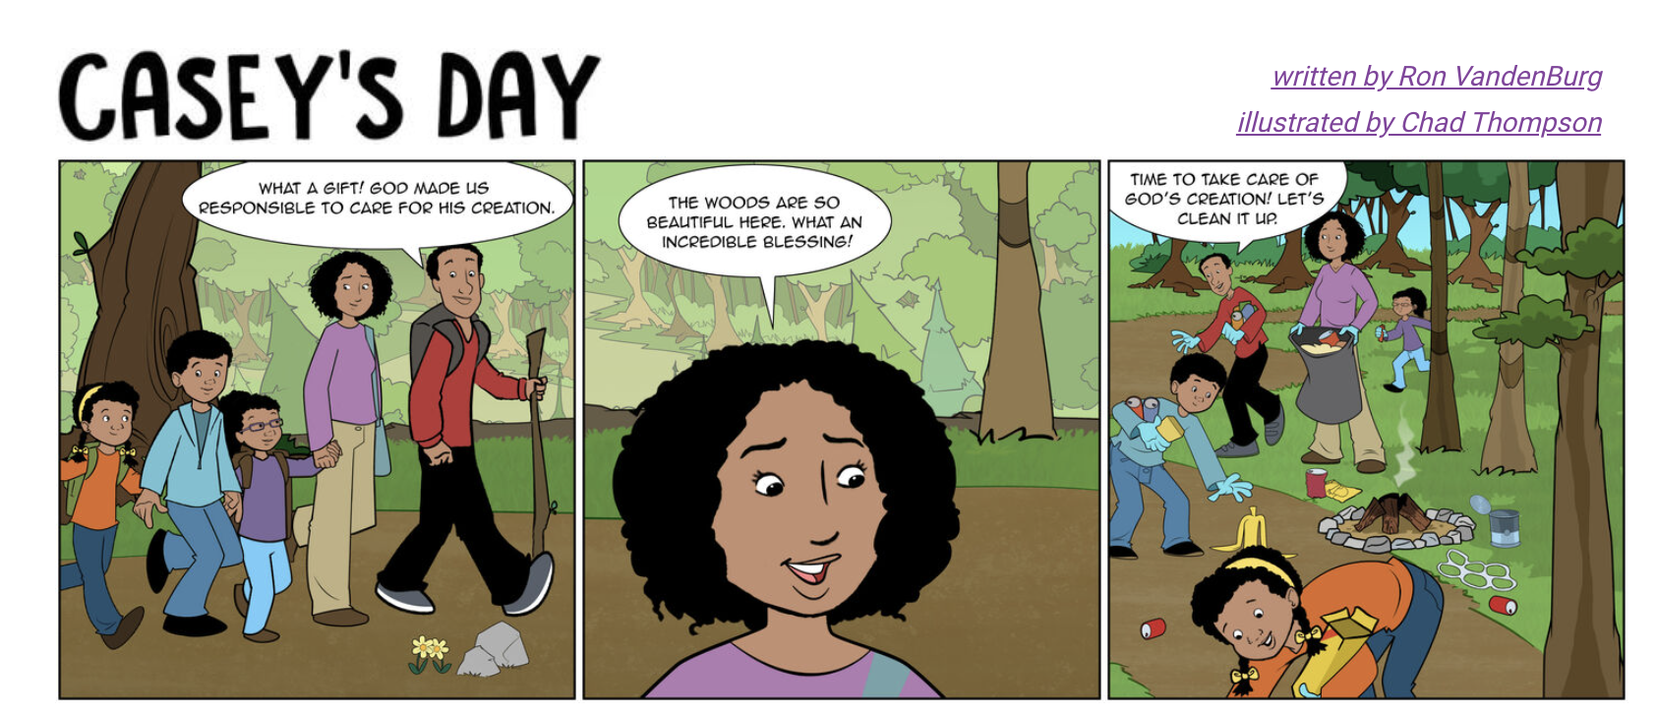

When God created the earth, he made sure to make everything just right. After every day of creation, he looked at what he had made and called it good. That meant it was complete, correct, and just how he intended it to be. And then—at the very end of creation—God gave it all to us and put us in charge of it all. That is an incredible blessing and a huge task!
It is a blessing because it lets us know that God trusts us so much that he gave us the gift of his creation. Every fantastic sunset or beautiful mountain you see is a blessing from God. It communicates his love and care for this world and you.
It is a huge task because creation needs to be cared for. Like anything else, people can abuse creation and destroy it if it isn’t taken care of correctly. You have a massive impact on this world and must choose whether that will be positive or negative. When God put his people in charge of creation, he wanted us to use its resources, watch over it, plan for the best, and look after his world.
Earth Day is a time to celebrate what God has blessed you with. He has created a fantastic world for you to live in and enjoy. Take some time this week to remember God’s blessings and enjoy them! This week is also a time to remember the task that God has given you. Take that responsibility seriously and do something to take care of creation today.

Prayer
Creator God, thank you for creating this amazing world for me! Show me how you want me to take care of it and enjoy it every day. Amen.
https://kidscorner.net/devotions/earth-day

